**1.Modelo RF5_Indeg Apoio Spe tubos X All var**.

***Instrucciones modelo***: **test size = 0.23 ; rd_state = 3.**

***Variables indep select to fit***:

variables = ['id', 'Indeg_IntimAmigos_', '1_VarExp_Moranca', '2_VarExp_Atri_Tabanca', 'Area_bolanha', Degree Family; 'OutDeg_RedeRisk_Cen','OutDeg_RedeConfianc']

***Model performance (scores):***

Mean Squared Error: 0.4

R^2 Score: 0.4864 (In Excel: R2 = 0.526 ; y = 0.4322 X + 1.0228)

**Model tot:**

Mean Squared Error (MSE): 0.2713

Root Mean Squared Error (RMSE): 0.5209

Mean Absolute Error (MAE):0.2558

R^2 Score: 0.7349

Pearson Correlation: 0.8703

***Interactions***:

|  | **Interacción** | **Importancia** | **Dirección** |
| --- | --- | --- | --- |
| 0 | (1_VarExp_Moranca, Area_bolanha) | 0.237641 | 0.002105 |
| 1 | (2_VarExp_Atri_Tabanca, Area_bolanha) | 0.233476 | 0.178090 |
| 2 | (Area_bolanha, OutDeg_RedeConfianc) | 0.224940 | 0.010708 |
| 3 | (Indeg_IntimAmigos_, Area_bolanha) | 0.220684 | 0.010063 |
| 4 | (1_VarExp_Moranca, 2_VarExp_Atri_Tabanca) | 0.213983 | 0.000816 |
| 5 | (Degree_RedeTotFamil, Area_bolanha) | 0.208006 | 0.024624 |
| 6 | (2_VarExp_Atri_Tabanca, OutDeg_RedeConfianc) | 0.201874 | 0.249835 |
| 7 | (1_VarExp_Moranca, OutDeg_RedeConfianc) | 0.183369 | 0.005936 |
| 8 | (Indeg_IntimAmigos_, 1_VarExp_Moranca) | 0.179430 | 0.010796 |
| 9 | (Indeg_IntimAmigos_, 2_VarExp_Atri_Tabanca) | 0.173590 | 0.013690 |

***Key results****:*

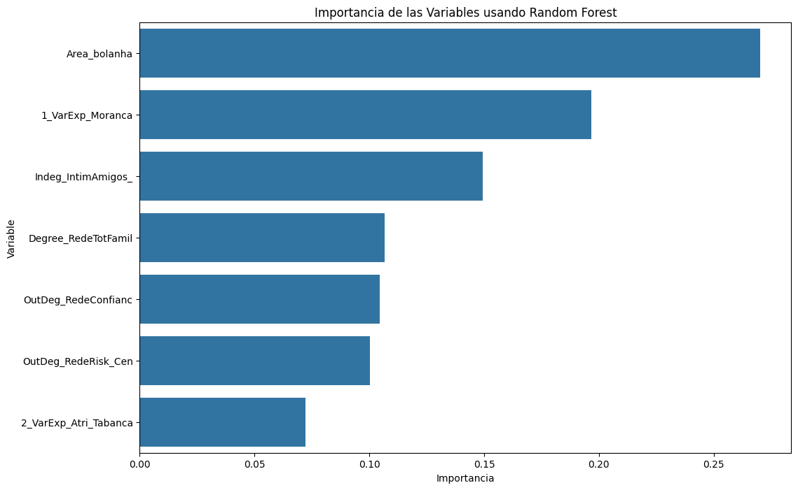 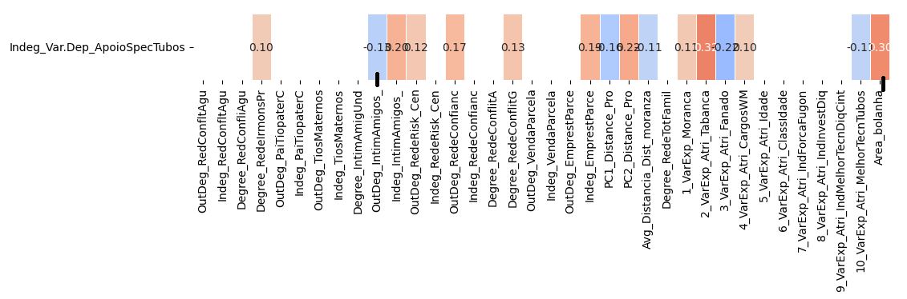

**1.Modelo RF5_Outdeg Apoio Spe tubos X All var**.

***Instrucciones modelo***: **test size = 0.23 ; rd_state = 3**

***Variables indep select to fit***:

variables = ['id', Indeg_IntimAmigUnd', 'Indeg_RedeConfianc', 'Degree_RedeTotFamil', '7_VarExp_Atri_IndForcaFugon', '9_VarExp_Atri_IndMelhorTecnDiqCint', '10_VarExp_Atri_MelhorTecnTubos']

***Model performance (scores):***

Mean Squared Error: 0.4333

R^2 Score: 0.9291 (on excel: **R2= 0.9465 ; Y = 0.8188 X + 0.1056**)

**Model tot:**

Mean Squared Error (MSE): 5.3721

Root Mean Squared Error (RMSE): 2.3178

Mean Absolute Error (MAE): 0.4574

R^2 Score: 0.9332

Pearson Correlation: 0.993

***Interactions***:

| **Interacción** | **Importancia** | **Dirección** |
| --- | --- | --- |
| 0 | (Indeg_RedeConfianc, 10_VarExp_Atri_MelhorTecn... | 11.408878 | 1.099170 |
| 1 | (7_VarExp_Atri_IndForcaFugon, 10_VarExp_Atri_M... | 11.250491 | 0.898235 |
| 2 | (Indeg_IntimAmigos_, 10_VarExp_Atri_MelhorTecn... | 11.170840 | 0.098909 |
| 3 | (Degree_RedeTotFamil, 10_VarExp_Atri_MelhorTec... | 10.917921 | 0.118578 |
| 4 | (9_VarExp_Atri_IndMelhorTecnDiqCint, 10_VarExp... | 10.857250 | 0.124384 |
| 5 | (Indeg_RedeConfianc, 7_VarExp_Atri_IndForcaFugon) | 3.169050 | 1.105053 |
| 6 | (Indeg_IntimAmigos_, Indeg_RedeConfianc) | 2.502028 | 0.062480 |
| 7 | (Indeg_RedeConfianc, Degree_RedeTotFamil) | 2.493367 | 1.105166 |
| 8 | (Indeg_RedeConfianc, 9_VarExp_Atri_IndMelhorTe... | 2.480166 | 1.087512 |
| 9 | (7_VarExp_Atri_IndForcaFugon, 9_VarExp_Atri_In... | 1.535761 | 0.874348 |

***Key results****:*



